Abhinav Srivatsa

21BDS0340

Computer Science Lab

Problem Set 3

**Question 1**

**Code:**

import re

sen = input()

words = sen.split(' ')

start = input()

end = input()

for i in words:

    # checking if I starts with start variable

    if re.match('^' + start, i.lower()):

        print(i)

for i in words:

    # checking if I ends with end variable

    if re.match('.*' + end + '$', i.lower()):

        print(i)

**Algorithm:**

Import Regex

Read Sentence

Initialise Words by splitting Sentence by space

Read Start

Read End

Loop through Words with I

If lowercase I starts with Start

Display I

Loop through Words with I

If lowercase I ends with End

Display I

**Output:**

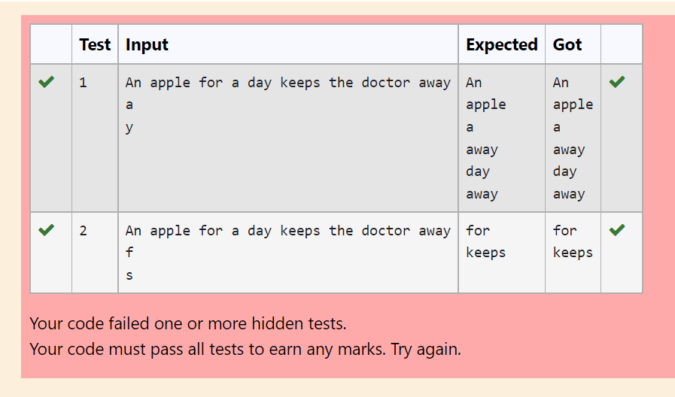

**Question 2**

**Code:**

import re

sen = input()

words = sen.split(' ')

start = input()

end = input()

for i in words:

    # checking if I starts with start variable and ends with end variable

    if re.match('^' + start, i.lower()) and re.match('.*' + end + '$', i.lower()):

        print(i)

**Algorithm:**

Import Regex

Read Sentence

Initialise Words by splitting Sentence by space

Read Start

Read End

Loop through Words with I

If lowercase I starts with Start and ends with End

Display I

**Output:**

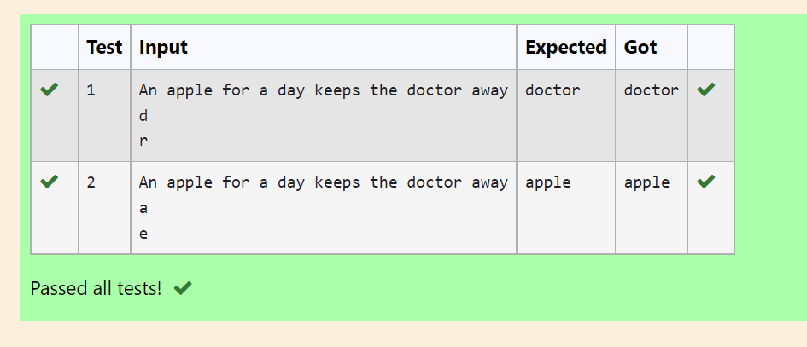

**Question 3**

**Code:**

def Check_21BDS0340(Parameter):

    # getting length of Parameter

    string_length = len(Parameter)

    # getting last character of Parameter

    end_character = int(Parameter[-1])

    # return whether they are the same

    return string_length == end_character

string = input()

print(Check_21BDS0340(string))

**Algorithm:**

Check_21BDS0340(String Param):

Initialise String_Length as length of Param

Initialise End_Character as the last character of Param and convert it to integer

Return True if String_Length equals End_Character, else return False

Read String as input

Display Check_21BDS0340(String)

**Output:**

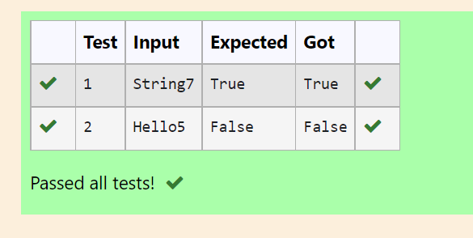

**Question 4**

**Code:**

def Salary_21BDS0340(List):

    # initialising min and max salaries and ids

    max_salary = min_salary = List[0]['salary']

    max_id = min_id = List[0]['id']

    # finding max salary

    for i in List:

        if i['salary'] > max_salary:

            max_salary = i['salary']

            max_id = i['id']

    # finding min salary

    for i in List:

        if i['salary'] < min_salary:

            min_salary = i['salary']

            min_id = i['id']

    print(max_id)

    print(min_id)

List = eval(input())

Salary_21BDS0340(List)

**Algorithm:**

Salary_21BDS0340(list List):

Initialise Max_Salary and Min_Salary as the first salary field in List

Initialise Max_Id and Min_Id as the first id field in List

Loop through List as I

If I’s Salary > Max_salary

Max_Salary is now I’s Salary

Max_Id is now I’s Id

Loop through List as I

If I’s Salary < Min_salary

Min_Salary is now I’s Salary

Min_Id is now I’s Id

Display Max_Id

Display Min_Id

Read List as evaluated input

Call Salary_21BDS0340(List)

**Output:**

